**SQL Task**

**The ERD diagram:** 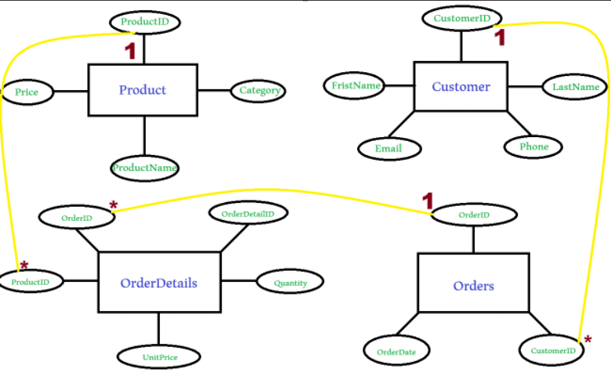

**SQL scripts for:**

1- Creating the database & tables (DDL):

create database Store;

use Store;

create table Customers(

CustomerID int primary key,

FristName varchar(100),

LastName varchar(100),

Email varchar(100),

Phone varchar(100)

);

create table Products(

ProductID int primary key,

ProductName varchar(100),

Caregory varchar(100),

Price int

);

create table Orders(

OrderID int primary key,

OrderDate date,

CustomerID int

);

create table orderDetails(

OrderDetailID int primary key,

OrderID int,

ProductID int,

Quantitty int,

UnitPrice int

);

2- Inserting data (DML):

insert into Customers(CustomerID,FristName,LastName,Phone,Email) values

(1,'Mohab','Ahmed','01033079606','mohab.ahmed.ntss@gmail.com'),

(2,'Ali','Fathy','01057830243','ali.fathy@gmail.com'),

(3,'Hosam','Mohamed','01069723854','hosam.mohamed@gmail.com')

;

insert into Products(ProductID,ProductName,Caregory,Price) values

(101,'HP EliteBook 840 G6','Electronics',20000),

(102,'Sofa 3*1','Furniture',2500),

(103,'Itel A70','Electronics',4000)

;

insert into Orders(OrderID,OrderDate,CustomerID) values

(201,'2025-3-1',1),

(202,'2025-8-30',2)

;

insert into orderDetails(OrderDetailID,OrderID,ProductID,Quantitty,UnitPrice) values

(1,201,101,2,20000),

(2,201,103,1,4000),

(3,202,102,4,2500),

(4,202,103,2,4000) ;

3- Running analysis queries (DQL):

select FristName,LastName,Phone

from Customers;

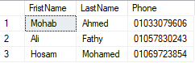

select ProductName

from Products

where Price > 100;

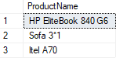

select O.OrderID,C.FristName,O.OrderDate

from Orders O

left join Customers C on O.CustomerID=C.CustomerID;



select SUM(Quantitty*UnitPrice) As TotalRevenue

from orderDetails;



select P.ProductName,SUM(OD.Quantitty) AS TotalQuantitySold

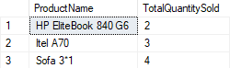from OrderDetails OD

inner join Products P ON OD.ProductID = P.ProductID

group by P.ProductName;